37.BAR GRAPHS
----------------------------------------------------

this section comprises of questions in which the data collected in a particular discipline are represented in the form of vertical or horizontal bars drawn by selecting a particular scale.one of the parameters is plotted on the horizontal axis and the other on the vertical axis . the candidate is required to understand the given information and thereafetr answer the given questions on the basis of data analysis.

1.The bar graph given below shows the foreign exchange reserves of a country
(in million us$)
from 1991-92 to 1998-99 .answer the questions based
on this graph.

FOREIGN EXCHANGE RESERVES OF A COUNTRY
(IN MILLION US $)

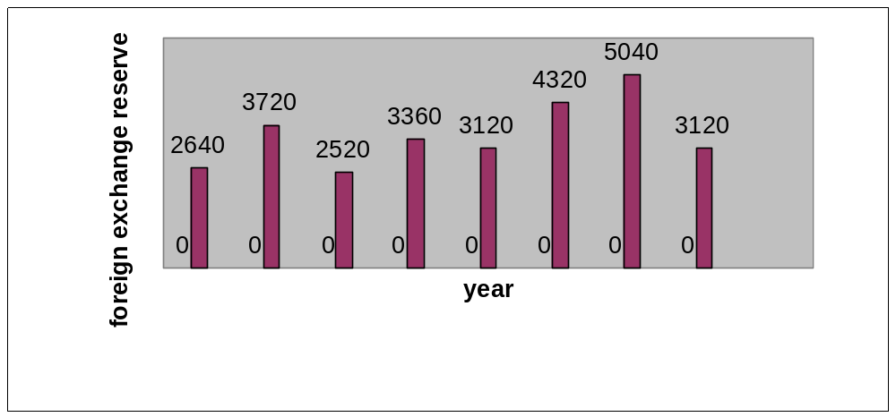

1.The foreign exchange reserves in 1997-98 was how ,any times that in 1994-95?
(a)0.7 (b) 1.2 (c) 1.4 (d) 1.5 (e) 1.8
2.what was the percentage increase in the foreign exchange reserves in 1997-98 over 1993-94?
(a)100 (b)150 (c)200 (d)620 (e)2520

3.for which year,the percent increase of foreign exchange reserves over the previous year,is the highest?
(a)1992-93 (b)1993-94 (c)1994-95 (d)1996-97 (e)1997-98

4.the foreign exchange reserves in 1996-97 werw approximately what percent of the average foreign exchange reserves over the period under review?
(a)95% (b)110% (c)115% (d)125% (e)140%

5.the ratio of the number of years,in which the foreign exchange reserves are above the average reserves ,to those in which the reserves are below the average reserves is :
(a)2:6 (b)3:4 (c)3:5 (d)4:4 (e)5:3

Solutions
1 (d) : required ratio = 5040/3360 = 1.5
2 (a) : foreign exchange reserve in 1997-98=5040 million us $
foreign exchange reserves in 1993-94=2520 million us$
therefore increase=(5040-2520)=2520 million us $
therefore percentage increase=((2520/2520)*100)%=100%
3(a): there is an increase in foreign exchange reserves during the years 1992- 93,1994-951996-97,1997-98 as compared to previous year (as shown by bar graph)
the percentage increase in reserves during these years compared to previous year are
(1) for 1992-93 =[(3720-2640)/2640*100]% =40.91%
(2) for 1994-95=[(3360-2520)/2520*100]%=33.33%
(3) for 1996-97=[(4320-3120)/3120*100]%=38.46%
(4) for 1997-98=[(5040-4320)/4320*100]%=16.67%

Clearly, the percentage increase over previous year is highest for 1992-93.

4. (d) : Average foreign exchange reserves over the given period
= [_x (2640 + 3720 + 2520 + 3360 + 3120 + 4320 + 5040 + 3120) ] million US $
= 3480 million US $.
Foreign exchange reserves in 1996-97 = 4320 million US $. . .
Required Percentage = x 100 % = 124.14% .. 125%.
3480 .

5. (c) : Average foreign exchange reserves over the given period = 3480 million US $.
The country had reserves above 3480 million US $ during the years 199293, 1996-97 and 1997-98 i.e., for 3 years and below 3480 million US $ during the years 1991-92, 1993-94, 1994-95, 1995-96 and 1998-99 i.e., for 5 years.
Hence, required ratio = 3 : 5.

Ex. 2. The bar-graph provided on next page gives the sales of books (in thousand numbers) from six branches of a publishing company during two consecutive years 2000 and 2001. Answer the questions based on this bar-graph:

Sales of books (in thousand numbers) from six branches-B1,B2,B3,B4,B5 and B6 of a publishing company in 2000 and 2001

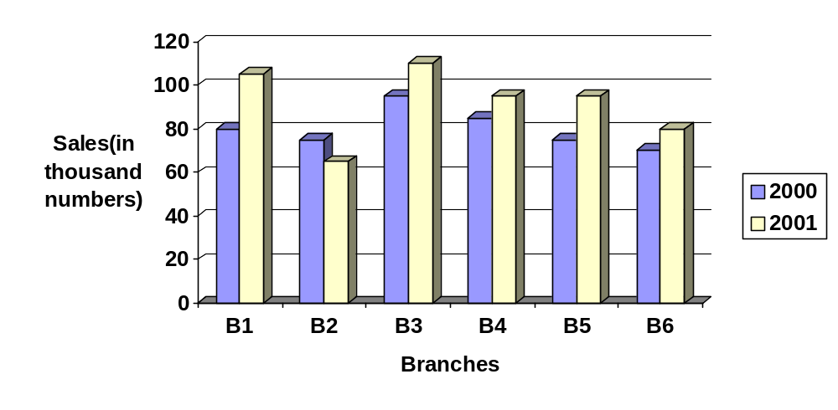

1.total sales of branches b1,b3 and b5 together for both the years (in thousand numbers) is:
(a)250 (b) 310 (c) 435 (d)560 (e)585

2.total sales of branch b6 for both the years is what percent of the total sales of branch b3 for both the years?
(a) 68.54% (b)71.11% (c) 73.17% (d)75.55% (e)77.26%

3.what is the average sale of all the branches (in thousand numbers) for the year 2000?
(a)73 (b)80 (c)83 (d)88 (e)96

4.what is the ratio of the total sales of branch b2 for both years to the total sales of branch b4 for both years ?
(a)2:3 (b)3:5 (c)4:5 (d)5:7 (e)7:9

5.what percent of the average sales of branchesn b1,b2 and b3 in 2001 is the average sales of branches b1,b3 and b6 in 2000?
(a)75% (b)77.5% (c)82.5% (d)85% (e)87.5%

SOLN…………………..
1.(d) total sales of branches B1,B3 and B5 for both the years (in thousand numbers)=(80+105)+(95+110)+(75+95)=560

2(c) required percentage=[(70+80)/(95+110)*100]%=(150/205*100)%=73.17%

3(b)average sales of all the six branches (in thousand numbers ) for the year 2000=1/6*(80+75+95+85+75+70)=80

4(e) required ratio=(75+65)/(85+95)=140/180=7/9

5(e)average sales(in thousand numbers of branches B1,B3,and B6 in 2000= 1/3*(80+95+70)=245/3

average sales(in thousand numbers of branches B1,B2,and B3 in 2001=1/3*(105+65+110)=280/3

therefore required percentage=[((245/3)/(280/3))*100]%=(245/280*100)%=87.5%

Ex.3. The bar graph provided below gives the data of the production of paper (in thousand tonnes) by three different companies x,y and z over the years .study the graph and answer the questions that follow
production of paper(in laks tonnes) by three companys x,yand z over the years

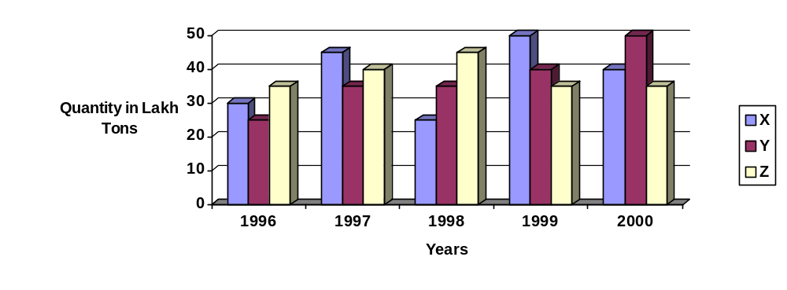

1.What is the difference between the production of the company Z in 1998 and company y in 1996?
a.2 ,00,000 tons
b.20,00,000 tons
c.20,000 tons
d.2,00,00,000 tons
e.none of these

2.what is the ratio of the average production of company x in the period 1998 to 2000 to the average production of company y in the same period?
a.1:1
b.15:27
c.23:25
d.27:29
e.none of these

3.what is the percentage increase in the production of company y from1996 to 1999?
a.30%
b.45%
c.50%
d.60%
e.75%

4.the avreage production of five years was maximum for which company?
a.x
b.y
c.z
d.x & y both
e.x and z both

5.for which of thw follolwing years the percentage rise / fall in production from previous year is the maximum for company y?
a.1997
b.1998
c.1999
d.2000
e.1997 & 2000

6.in which year was the percentage of production of company z to the production of company y the maximum?
a.1996
b.1997
c.1998
d.1999
e.2000
Sol: 1(b):required difference =
[(45-25)*i,00,000]tons=20,00,000 tons

2(c):average production of company x in the period 1998-2000=[1/3*(25+50+40)]=(115/3) lakh tons

average production of company y in the period 1998-2000
[1/3*(35+40+50)]=(125/3) lakh tons

therefore req ratio=(115/3)/(125/3)=115/125=23/25

3(d):percentage increase in the production y from 1996-1999=[(40-25)/25*100]%=(15/25*100)%=60%

4(e):average production (in lakh tons)in five years for the three company’s are:
for company x=[1/5*(30+45+25+50+40)]=190/5=38
for company y=[1/5*(25+35+35+40+50)]=185/5=37
for company z=[1/5*(35+40+45+35+35)]=190/5=38
therefore the average production of maximum for both the company’s x and z

5(a) : Percentage change (rise/fall)in the production of Company Y in comparison to the previous year, for different years are:
For 1997 = [((32-25)/25)*100]% = 40%
For 1998 = [((35-35)/25)*100]% = 0%
For 1999 = [((40-35)/35)*100]% = 14.29%
For 2000 = [((50-40)/40)*100]% = 25%

Hence, the maximum percentage rise/fall in the production of company Y is for 1997.

6(a) : The percentages of production of company z to the production of company z for various years are:
For 1996 = ((35/25)*100)%=140%; For 1997 = ((40/35)*100)% = 114.29%
For 1998 = ((45/35)*100)%=128.57%; For 1999 = ((35/40)*100)%=87.5%
For 2000 = ((35/50)*100)%=70%

Clearly, this percentage is highest for 1996.

Ex.4.Outof the two bar graphs provided below, one shows the amounts (in Lakh Rs) invested by a Company in purchasing raw materials over the years and the other shows the values(in Lakh Rs.) of finished goods sold by the Company over the years.
Study the two bar graphs and answer the questions based on them.
Amount Invested in Raw Materials and the Value of Sales of Finished Goods for
a Company over the Years

Amount Invested in Raw Materials (Rs. in Lakhs)

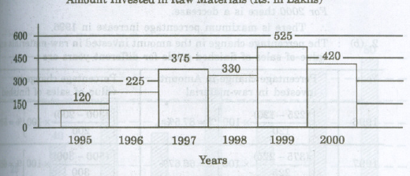

Value of Sales of Finished Goods(Rs.in Lakhs)

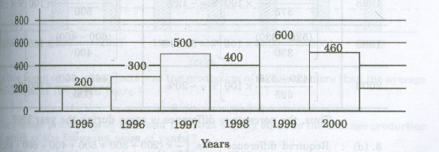

1.Inwhichyear,there has been a maximum percentage increase in the amount invested inRawMaterials as compared to the previous year?
(a)1996 (b) 1997 (c) 1998 (d) 1999 (e) 2000
2. Inwhichyear, the percentage change (compared to the previous year) in the investment onRaw Materials is the same as that in the value of sales of finished goods?
(a)1996 (b) 1997 (c) 1998 (d) 1999 (e) 2000
3.Whatwas the difference between the average amount invested in Raw Materials during the given period and the average value of sales of finished goods during this period?
(a)Rs. 62.5 lakhs (b) Rs. 68.5 lakhs (c) Rs. 71.5 lakhs
(d)Rs.77.51akhs (e) Rs. 83.5 lakhs

4. The value of sales of finished goods in 1999 was approximately what percent of the average amount invested in Raw Materials in the years 1997,1998 and 1999?
(a) 33% (b) 37% (c) 45% (d) 49% (e) 53%

5. The maximum difference between the amount invested in Raw Materials and the value of sales of finished goods was during the year:
(a) 1995 (b) 1996 (c) 1997 (d) 1998 (e) 1999

Sol. 1. (a) : The percentage increase in the amount invested in raw-materials as compared to the previous year, for different years are:
For 1996 = [((225-120)/120)*100]% = 87.5%
For 1997 = [((375-225)/225)*100]% = 66.67%
For 1998 = [((525-330)/330)*100]% = 59.09%
For 2000 there is a decrease.
2.(b)The percentage change in the amount invested in raw-materials and in the value of sales of finished goods for different years are:

year | Percentage change in amount invested in raw-materials | Percentage change in value of sales of finished goods
1996 | [((225-120)/120)*100]% = 87.5% | [((300-200)/200)*100]% = 50%
1997 | [((375-225)/225)*100]% = 66.7% | [((500-300)/300)*100]% = 66.67%
1998 | [((525-330)/330)*100]% = -12% | [((400-500)/500)*100]% = -20%
1999 | [((525-330)/330)*100]% = 59.09% | [((600-400)/400)*100]% = 50%
2000 | [((420-525)/525)*100]% = -20% | [((460-600)/600)*100]% = -23.33%

Thus the percentage difference is same during the year 1997.

3. (d) : Required difference = Rs. [(1/6)*(200+300+500+400+600+460)
- (1/6)*(120+225+375+330+525+420)] lakhs
= Rs. [(2460/6)-(1995/6)] lakhs = Rs.(410-332.5)lakhs = 77.5 lakhs.

4. (d) : Required percentage = [(600/(375+300+525))*100]% = 48.78% ≈ 49%

5. (c) : The difference between the amount invested in raw-material and the value of sales of finished goods for various years are :
For 1995 = Rs.(200-120)lakhs = Rs. 80 lakhs
For 1996 = Rs.(200-225)lakhs = Rs. 75 lakhs
For 1997 = Rs. (500-375)lakhs = Rs. 125 lakhs
For 1998 = Rs. (400-330)lakhs = Rs. 70 lakhs.
For 1999 = Rs. (600-525)lakhs = Rs. 75 lakhs
For 2000 = Rs. (460-420)lakhs = Rs. 40 lakhs.
Clearly, maximum difference was during 1997
--------------------------------------------------------------------------------
EXERCISE 37

Directions(questions 1 to 5) : study the following bar-graph and answer the questions given below.
Production of fertilizers by a Company (in 10000 tonnes) over the Years

X axis=years
Y axis=Production (in 10000 tonnes)
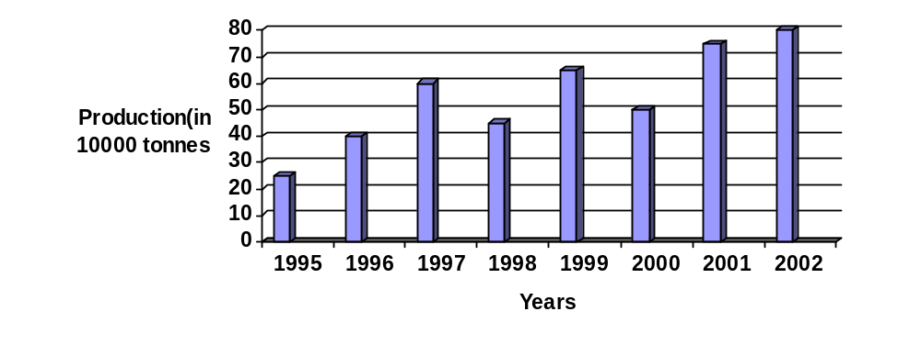

1. In how many of the given years was the production of fertilizers more than the average production of the given years?

(a)1 (b)2 (c)3 (d)4 (e)5
2. The average production of 1996 and 1997 was exactly equal to the average production of which of the following pairs of years?

(a)2000 and 2001 (b)1999 and 2000 (c)1998 and 2000 (d)1995 and 1999 (e)1995 and 2001
3.What was the percentage decline in the production of fertilizers from 1997 to 1998?
(a) 33¹/₃% (b) 30% (c) 25% (d) 21% (e) 20%
4.In which year the percentage increase in production as compared to the previous year the maximum?
(a) 2002 (b) 2001 (c) 1999 (d) 1997 (e) 1996

